**Statisical analysis of differential taxa by treatment group.**

Ruminococcus is ALMOST statistically significant between the two fiber groups at the end of treatment (reduction in Group B). 🡪 B: whole grain

k__Bacteria;p__Firmicutes;c__Clostridia;o__Clostridiales;f__Ruminococcaceae;g__Ruminococcus

q-value = 0.0627, Group B estimate = -0.0756

**Comparison of alpha-diversity between groups.**

There appear to be differences in alpha diversity based on the starting points of the two groups, although these converge at the end of the treatments.

Using t-test (at sampling depth = 19490)

Group A vs. Group B; Timepoint 1

p-value = 0.01266

Group A vs. Group B; Timepoint 2

p-value = 0.106

**Comparison of beta-diversity between groups.**

Unweighted Unifrac (Red = Group A; Blue = Group B; Both timepoints)

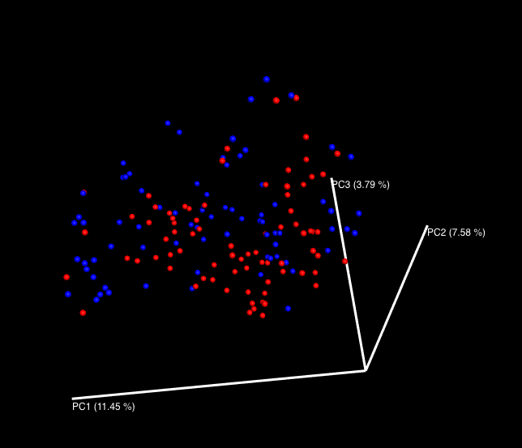

Using Unweighted Unifrac, there is a significant difference between Group A and Group B at time point 1, and almost at timepoint 2

Time 1 Unweighted Unifrac P-value = 0.05

Time 2 Unweighted Unifrac P-value = 0.07

Time 1 Weighted Unifrac P-value = 0.39

Time 2 Weighted Unifrac P-value = 0.25

**Predictive modeling of clinical covariates by microbiome composition**

The microbiome at timepoint 1 was used to predict the change in these clinical variables (stratified by fiber intervention).

|  |  |  |  |  |  |  |  |  |
| --- | --- | --- | --- | --- | --- | --- | --- | --- |
| FM |  |  |  |  |  |  |  |  |
| A | RSME | 2.056620903 | SD RSME | 0.012642301 | Normalized RSME | 0.297259434 | SD Normalized RSME | 0.00182729 |
| B | RSME | 1.876369689 | SD RSME | 0.016084893 | Normalized RSME | 0.215912926 | SD Normalized RSME | 0.001850881 |
| CD4Naive |  |  |  |  |  |  |  |  |
| A | RSME | 16.87477493 | SD RSME | 0.083519892 | Normalized RSME | 0.203065884 | SD Normalized RSME | 0.001005053 |
| B | RSME | 13.60786348 | SD RSME | 0.051581378 | Normalized RSME | 0.201897084 | SD Normalized RSME | 0.000765302 |
| StoolWt |  |  |  |  |  |  |  |  |
| A | RSME | 163.63071 | SD RSME | 1.196995516 | Normalized RSME | 0.255174596 | SD Normalized RSME | 0.00186666 |
| B | RSME | 201.6950562 | SD RSME | 1.273138681 | Normalized RSME | 0.234602789 | SD Normalized RSME | 0.001480859 |
| StoolEn |  |  |  |  |  |  |  |  |
| A | RSME | 319.7314276 | SD RSME | 2.314399622 | Normalized RSME | 0.221574101 | SD Normalized RSME | 0.001603881 |
| B | RSME | 329.4676974 | SD RSME | 2.874568056 | Normalized RSME | 0.20945181 | SD Normalized RSME | 0.001827443 |
| ARB |  |  |  |  |  |  |  |  |
| A | RSME | 7.62111855 | SD RSME | 0.045680318 | Normalized RSME | 0.165656419 | SD Normalized RSME | 0.00099293 |
| B | RSME | 39.10260407 | SD RSME | 0.311220464 | Normalized RSME | 0.236685712 | SD Normalized RSME | 0.001883799 |
| Tdiam24hr |  |  |  |  |  |  |  |  |
| A | RSME | 21.90350722 | SD RSME | 0.102319935 | Normalized RSME | 0.21265541 | SD Normalized RSME | 0.000993397 |
| B | RSME | 13.97202003 | SD RSME | 0.075541543 | Normalized RSME | 0.25636734 | SD Normalized RSME | 0.001386083 |
| ConA_5ug_per_ml | |  |  |  |  |  |  |  |
| A | RSME | 7035.624139 | SD RSME | 28.45064598 | Normalized RSME | 0.210174432 | SD Normalized RSME | 0.000849903 |
| B | RSME | 11435.67554 | SD RSME | 59.6862905 | Normalized RSME | 0.224086864 | SD Normalized RSME | 0.001169578 |
| Plasma_IL_6 | |  |  |  |  |  |  |  |
| A | RSME | 1.802771014 | SD RSME | 0.01279103 | Normalized RSME | 0.168809389 | SD Normalized RSME | 0.001197737 |
| B | RSME | 2.982356429 | SD RSME | 0.018974949 | Normalized RSME | 0.145317233 | SD Normalized RSME | 0.000924567 |
| LPS_TNF_a |  |  |  |  |  |  |  |  |
| A | RSME | 7735.619034 | SD RSME | 42.89648343 | Normalized RSME | 0.232967262 | SD Normalized RSME | 0.001291878 |
| B | RSME | 5783.48392 | SD RSME | 36.12260943 | Normalized RSME | 0.188808056 | SD Normalized RSME | 0.001179261 |
| Iso |  |  |  |  |  |  |  |  |
| A | RSME | 231.5294175 | SD RSME | 1.361342541 | Normalized RSME | 0.223338723 | SD Normalized RSME | 0.001313183 |
| B | RSME | 296.0775461 | SD RSME | 1.5671189 | Normalized RSME | 0.225756856 | SD Normalized RSME | 0.001194916 |

**Statisical analysis of associations between taxa and metadata**

These represent significant interaction terms between the fiber intervention and change in the respective clinical variable, when regressing clinical covariates on relative abundances of various taxon (corrected for the number of taxon comparisons but not for the clinical variables).

**Genus Level**

"StoolWt"

k__Bacteria;p__Proteobacteria;c__Gammaproteobacteria;o__Aeromonadales;f__Succinivibrionaceae;g__Succinivibrio

0.06498783

**Phylum Level**

"StoolWt"

k__Bacteria;p__Proteobacteria

0.09796699

**PROBLEMS**

* Missing Samples in mapping file

"Sample.66.1", "Sample.25.1", "Sample.105.2", "Sample.13.2", "Sample.13.1", "Sample.30.1", "Sample.30.2", "Sample.39.2", "Sample.87.2", "Sample.87.1", "Sample.6.2", "Sample.6.1", "Sample.39.1", "Sample.99.2", "Sample.99.1", "Sample.66.2", "Sample.25.2", "Sample.76.1", "Sample.105.1", "Sample.76.2"

* Could not find ACETATE_1, BUTYRATE_1, ADJREE in mapping file